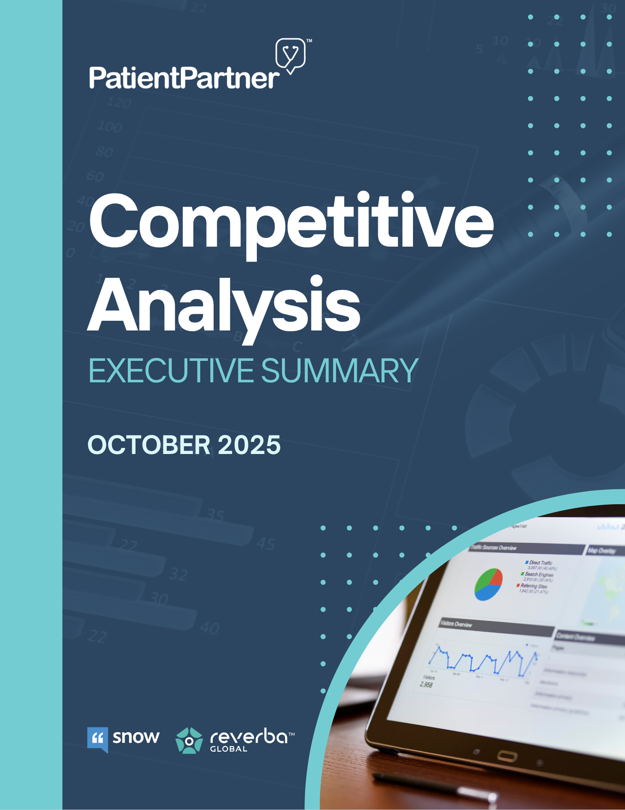

Table of Contents

Snow Companies & Reverba vs. PatientPartner 2
Executive Overview 2
Market Landscape & Competitor Profiles 2
PatientPartner Positioning 3
Roadmap & Strategic Opportunities 4
Strategic Outlook / Market Opportunity 5
Key Takeaways 5

Competitive Analysis Executive Summary

Snow Companies & Reverba vs. PatientPartner

1. Executive Overview
This report summarizes key findings from a competitive analysis of Snow Companies and Reverba, the two incumbent agencies in patient mentorship and ambassador programs for pharmaceutical and medical device companies.
Interviews with nine former employees revealed a stagnant, relationship-driven market dominated by manual operations, outdated technology, and weak data validation. Clients often remain with incumbents due to lack of alternatives, not satisfaction.
PatientPartner fills that gap, offering a technology-first mentorship platform that delivers scalable, compliant, and measurable patient engagement. The following sections outline the market landscape, competitive weaknesses, and PatientPartner’s roadmap for sustained differentiation and growth.

2. Market Landscape & Competitor Profiles
Market Overview
Pharma and med-device brands invest $300K–$1.5M annually per brand on patient mentorship and ambassador programs. Despite this spend, legacy providers have made little progress toward digitization, real-time reporting, or measurable ROI. The result is a market ripe for modernization, as brands seek scalable, transparent, and compliant solutions.
Competitor Profiles
- Snow Companies – A full-service agency focused on patient storytelling, creative production, and ambassador programs. Deeply embedded in pharma marketing workflows, Snow provides reliability but lacks technological innovation. Operations remain highly manual, with scalability limited by human oversight.
- Reverba – Positions itself as a “talent agency for patients,” managing ambassador networks and mentorship programs. Reverba’s emphasis on compliance and authenticity has earned trust, but its model depends on staff-monitored calls, manual matching, and Excel-based reporting.
“She was stuck working with us if she wanted the program.” - Former Reverba employee
Key Insights from Interviews
- Technology Deficit: Both competitors rely on outdated, manual systems (Excel, Microsoft Dynamics).
“If you can do anything that makes it techy, you’re gonna kill it.” — Former Client Partner
- Operational Inefficiency: Only one in ten interested patients completes a mentorship connection, wasting the majority of acquisition efforts.
- ROI Attribution Gap: Agencies report activity metrics, not treatment outcomes. Programs are perceived as marketing expenses, not measurable impact drivers.
- Compliance Bottlenecks: Every mentor call requires staff oversight for compliance, making scalability nearly impossible.
- Shift Toward Authenticity: Brands increasingly favor peer-driven programs that balance authenticity and compliance.
- Pricing Rigidity: Most contracts remain bundled annual SOWs, limiting flexibility and innovation.

3. PatientPartner Positioning
PatientPartner is the only technology-first mentorship platform purpose-built for healthcare. It facilitates secure, asynchronous chat mentorship between patients, caregivers, and trained peer mentors, supported by the Keyword Monitoring System (KMS) for automated compliance oversight.
Core Differentiators
- Technology-Driven: Real-time dashboards, automated mentor matching, and structured compliance tracking.
- Flexible Mentor Engagement Model: Supports both volunteer and compensated mentors, depending on client preference, without compromising authenticity or compliance.
- Compliance Automation: KMS automatically flags keywords and phrases defined by client-specific protocols (KPPs) for review, ensuring consistency and traceability across all programs.
- Data Transparency: Standardized metrics measure mentee readiness, satisfaction, and post-conversation intent - offering clients a clear picture of engagement performance.
- Scalability: Once deployed, new brands or geographies can launch quickly through modular templates and pre-defined workflows.

4. Roadmap & Strategic Opportunities
Looking ahead, PatientPartner should prioritize deeper data integration, advanced compliance intelligence, and expanding enterprise scalability to strengthen its market position and improve product adoption.
- HUB & Data-Lake Interoperability
Set up secure data integrations with HUB partners and brand databases to confirm when patients enroll, start treatment, or complete procedures. This allows PatientPartner to show verified results, not just intent, and gives clients real-time visibility into program impact.
- Refined ROI Methodology with Tokenization
Partner with tokenization vendors (e.g., Datavant, HealthVerity) to link de-identified claims and HUB datasets with PatientPartner engagement data. This enables privacy-preserving, patient-level attribution without handling PHI and brings true, verifiable ROI measurement to the mentorship space.
- Enhanced Compliance Intelligence (KMS Evolution)
Advance the KMS beyond keyword scanning to include AI-based contextual flagging (e.g., detecting “I stopped taking it because…”), AE trend analytics, and automated routing for AE documentation. All AE submissions will remain human-verified and compliant with pharmacovigilance (PV) protocols, while automation improves accuracy, speed, and consistency in compliance workflows.
- Scalable Mentor Supply & Engagement
Expand mentor sourcing through advocacy groups, KOL referrals, and patient communities. Standardize onboarding, training, and engagement quality tracking to ensure consistency across therapeutic areas and geographies.
- Enterprise Enablement & Global Readiness
Develop standardized onboarding playbooks, integration templates, and performance frameworks to support multinational program launches. This enables faster implementation timelines and stronger operational alignment with large enterprise clients.
Summary
PatientPartner’s foundation in technology, authenticity, and transparency differentiates it in a market long dominated by manual, agency-based operations. The current roadmap centers on integration, automation, and validation, linking into pharma’s data ecosystems, enhancing compliance intelligence, and verifying patient outcomes through tokenized data matching.

5. Strategic Outlook / Market Opportunity
The patient mentorship and engagement category remains lucrative yet under-innovated. Snow and Reverba hold long-standing contracts with top pharma brands, but their reliance on human labor and legacy systems is unsustainable.
Pharma’s expectations are shifting toward digital enablement, measurable ROI, and integrated data visibility. PatientPartner is positioned to meet these demands by serving as the first scalable mentorship infrastructure that combines compliance rigor, authenticity, and measurable outcomes.
Continued investment in integration with HUB systems and brand data platforms, AI-powered compliance, and tokenized ROI validation will cement PatientPartner’s role as the default technology platform for patient mentorship across both pharma and med-device sectors.
“They’re still faxing forms. If someone comes in with tech, it’s game over.” — Former Industry Executive

6. Key Takeaways
PatientPartner’s Current Strengths
- Purpose-built, scalable mentorship platform designed for healthcare.
- Flexible mentor model supporting both volunteer and compensated mentors.
- Keyword Monitoring System (KMS) enabling automated AE flagging and compliance tracking.
- Transparent, standardized performance dashboards across programs.
Strategic Focus Areas
- Integration with HUB vendors and brand data systems for verified ROI.
- Tokenized data linkage through partners such as Datavant or HealthVerity.
- AI-driven compliance capabilities, including contextual flagging and AE trend analytics.
- Global scalability through standardized onboarding, analytics, and integration frameworks.
Together, these priorities position PatientPartner to transform from an engagement platform into the core digital infrastructure for compliant, measurable patient mentorship across the healthcare industry.

